Software Requirements Specification

For

Android Smart Health Prediction Application

**Version 1.0 approved**

**Prepared by**

**Shaikh Humairaa**

**Shaikh Mehvish**

**Zunzunia Arsil**

**MHSSCOE**

**2nd February 2020**

**Table of Contents**

**Table of Contents Error! Bookmark not defined.**

**Revision History** 2

**1. Introduction Error! Bookmark not defined.**

1.1 Purpose **Error! Bookmark not defined.**

1.2 Document Conventions **Error! Bookmark not defined.**

1.3 Intended Audience and Reading Suggestions **Error! Bookmark not defined.**

1.4 Product Scope **Error! Bookmark not defined.**

1.5 References **Error! Bookmark not defined.**

**2. Overall Description Error! Bookmark not defined.**

2.1 Product Perspective **Error! Bookmark not defined.**

2.2 Product Functions **Error! Bookmark not defined.**

2.3 User Classes and Characteristics **Error! Bookmark not defined.**

2.4 Operating Environment **Error! Bookmark not defined.**

2.5 Design and Implementation Constraints **Error! Bookmark not defined.**

2.6 User Documentation **Error! Bookmark not defined.**

2.7 Assumptions and Dependencies **Error! Bookmark not defined.**

**3. External Interface Requirements Error! Bookmark not defined.**

3.1 User Interfaces 3

3.2 Hardware Interfaces **Error! Bookmark not defined.**

3.3 Software Interfaces **Error! Bookmark not defined.**

3.4 Communications Interfaces **Error! Bookmark not defined.**

**4. System Features Error! Bookmark not defined.**

4.1 System Feature 1 **Error! Bookmark not defined.**

4.2 System Feature 2 (and so on) **Error! Bookmark not defined.**

**5. Other Nonfunctional Requirements Error! Bookmark not defined.**

5.1 Performance Requirements 8

5.2 Safety Requirements **Error! Bookmark not defined.**

5.3 Security Requirements **Error! Bookmark not defined.**

5.4 Software Quality Attributes **Error! Bookmark not defined.**

5.5 Business Rules **Error! Bookmark not defined.**

**6. Other Requirements Error! Bookmark not defined.**

**Appendix A: Glossary Error! Bookmark not defined.**

**Appendix B: Analysis Models Error! Bookmark not defined.**

**Appendix C: To Be Determined List Error! Bookmark not defined.**

**Revision History**

|  |  |  |  |
| --- | --- | --- | --- |
| **Name** | **Date** | **Reason For Changes** | **Version** |
|  |  |  |  |
|  |  |  |  |

# Introduction

This section gives the scope and overview of everything included in this SRS document. Also, the purpose for this document is described.

## Purpose

## The Health Prediction application is an end user support and online consultation project. Here the proposed android application allows users to get instant guidance on their health issues through an intelligent health care application online. The application allows user to share their symptoms and issues and based on the input provided the system generates a result providing the information about the disease along with suggestions and precautions.

## Document Conventions

The document is written in IEEE format with standard conventions.

## Intended Audience and Reading Suggestions

Various patients who are in urgency of consultant, doctors who wish to develop such applications for their patients in order to keep records online, Analyst who wish to do analysis on the diseases, the data can also be reported to WHO so that they are aware of most severely growing disease region-wise.

## Product Scope

It might have happened so many times that you or someone yours need doctors help immediately, but they are not available due to some reason. The Health Prediction application is an end user support and online consultation project. Here we propose an android application that allows users to get instant guidance on their health issues through an intelligent health care application online. The application is fed with various symptoms and the disease/illness associated with those systems. The application allows user to share their symptoms and issues. It then processes user’s symptoms to check for various illness that could be associated with it. Here we use some intelligent data mining techniques to guess the most accurate illness that could be associated with patient’s symptoms. If the application is not able to provide suitable results, it urges users to go for blood test, x-ray, CITI scan or whichever report it feels user’s symptoms are associated with, so next time user may be able to login and upload an image of those reports. The application also has a doctor login, these uploaded images are now sent to respective doctor along with patient contact details. The doctors may now contact the patient for further process.

## References

*<List any other documents or Web addresses to which this SRS refers. These may include user interface style guides, contracts, standards, system requirements specifications, use case documents, or a vision and scope document. Provide enough information so that the reader could access a copy of each reference, including title, author, version number, date, and source or location.>*

# Overall Description

This section will give an overview of the whole system. The system will be explained in its context to show how the system interacts with other systems and introduce its basic functionality. It will also describe what type of stakeholders will use the system and what functionality is available for each type. Constraints and assumptions will also be presented.

## Product Perspective

This application can be used by all patients or their family members who need help in emergency.

## Product Functions

* Login/Logout :

The patients, doctors and Admin will have to login and logout for to ensure security of data shared.

* Role Based Access of each user :
* Admin can add new doctors and diseases and can view doctor details, patient details, disease details and feedbacks from users.
* Doctors can view patient’s personal details as well as patient’s case history.
* User / Patients can register themselves, view their personal details, specify the symptoms to predict the disease, search the doctors and give their feedbacks.
* On the basis of symptoms entered by the patient, the disease will be predicted and will be displayed to the patient along with relevant doctor details.

## User Classes and Characteristics

There are two user classes, Patient and Doctor.

* The Patients and Doctors are the primary users of this application and need to be accustomed to an internet connection.
* The verified doctors will be added to the application by Admin.
* The patient’s symptoms will direct him/her to the relevant disease and doctor.

## Operating Environment

* The application will work on mobile OS with android version (4.0 and above).
* Internet connection is mandatory.

## Design and Implementation Constraints

The application must be secure enough as patients personal details will be entered. Also, the application will be used by several users, so there should not be any problem related to multiple access at the same time.

## User Documentation

There will be options of Contact Us and About Us to assist users.

## Assumptions and Dependencies

# External Interface Requirements

This section provides a detailed description of all inputs into and outputs from the system. It also gives a description of the hardware, software and communication interfaces and provides basic prototypes of the user interface.

## User Interfaces

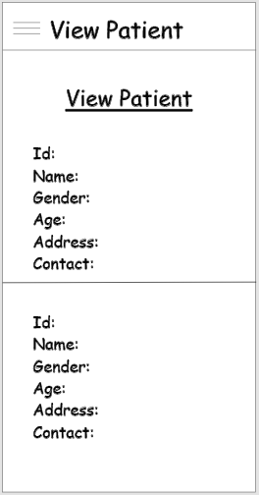

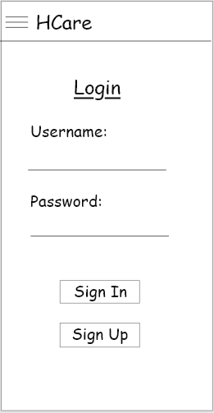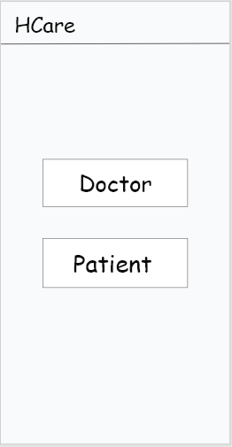



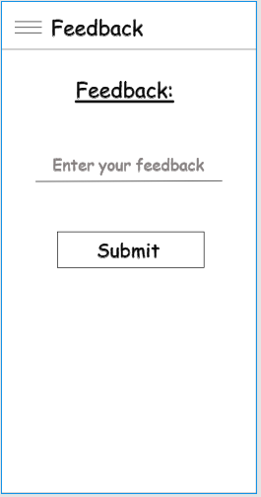

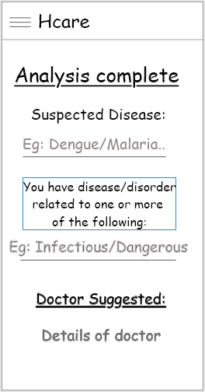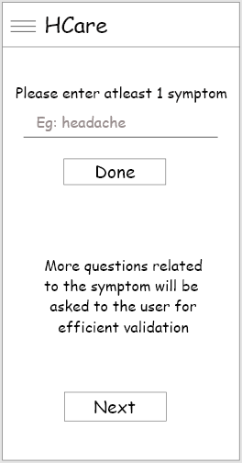

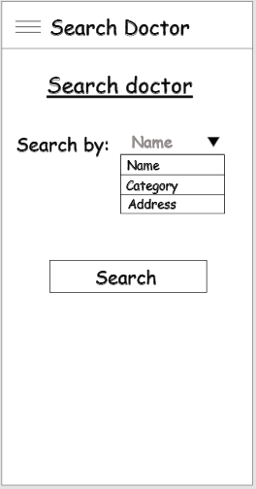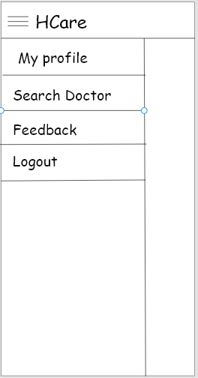

## Hardware Interfaces

Since the android application does not require any special hardware, there is no such hardware interface.

## Software Interfaces

1. Android Development Toolkit(ADT)

Android Development Tools (ADT) is a plugin for IDE that is designed to give you a powerful, integrated environment in which to build Android applications.

1. Microsoft Visual Studio

Microsoft **Visual Studio** is an integrated development environment (IDE) from Microsoft. It is used to develop computer programs, as well as websites, web apps, web services and mobile apps.

1. Microsoft SQL Server

Microsoft SQL Server is a relational database management system developed by Microsoft. As a database server, it is a software product with the primary function of storing and retrieving data as requested by other software applications—which may run either on the same computer or on another computer across a network.

1. Android 4.0 or higher

Android is a [mobile operating system](https://en.wikipedia.org/wiki/Mobile_operating_system) based on a modified version of the [Linux kernel](https://en.wikipedia.org/wiki/Linux_kernel) and other [open source](https://en.wikipedia.org/wiki/Open-source_software) software, designed primarily for [touchscreen](https://en.wikipedia.org/wiki/Touchscreen) mobile devices such as [smartphones](https://en.wikipedia.org/wiki/Smartphone) and [tablets](https://en.wikipedia.org/wiki/Tablet_computer).

## Communications Interfaces

*<Describe the requirements associated with any communications functions required by this product, including e-mail, web browser, network server communications protocols, electronic forms, and so on. Define any pertinent message formatting. Identify any communication standards that will be used, such as FTP or HTTP. Specify any communication security or encryption issues, data transfer rates, and synchronization mechanisms.>*

# System Features

This section gives an insight about the list of features that will be present in the system. The two applications will have different User Interfaces (i.e Patient and Doctor):

* 1. **Patient Registration**
     1. **Description and Priority**

Since this is the first step and authentication is essential step to ensure security, the priority of this feature is high.

**4.1.2 Stimulus/Response Sequences**

On launching Patient’s application in android device the first UI will have an Authentication page, users can either Login if the account is already created or they can Sign Up. If a user selects the Sign Up option they will be redirected to the Registration page which will ask for Registration Details. After Successful registration users will be redirected to the login page.

**4.1.3 Functional Requirements**

* The user (patient) will be asked to fill a Login form and it will be validated.
* If the user is a new one, he/she will be asked to register first and then login to the system using the credentials.
  1. **Patient Activities**

**4.2.1 Description and Priority**

After logging in the user will be redirected to the home page containing their personal details, their user will have a menu bar having various options to select ie they can search for disease, search for doctor, give feedback or logout. These are the main functionalities and thus, its priority is high.

**4.2.2 Stimulus/Response Sequences**

* In the search disease module, users will be asked for symptoms, then they will have multiple questions on various symptoms.
* In search for doctor module users can directly search for a doctor by entering their name.
* In the feedback module users can give feedback in the form of text.
* And by clicking the logout module they will be directly redirected to the login page.

**4.2.3 Functional Requirements**

* The symptoms selected by the user will be stored in the database and will be matched.
* The matched symptoms will generate the result.
* The doctors searched by the user will be fetched from the database and details will be given to the user.
* The feedback given by user will be stored for future.
  1. **Doctor Registration**
     1. **Description and Priority**

Since this is the first step and authentication is essential step to ensure security, the priority of this feature is high.

* + 1. **Stimulus/Response Sequences**

On launching Doctor’s application in android device the first UI will have an Authentication page, doctors have to Login first.

**4.3.3 Functional Requirements**

* The doctors will be asked to fill a Login form and it will be validated.
  1. **Doctor Activities**
     1. **Description and Priority**

After logging in the doctor will be redirected to the home page containing their personal details, their doctor will have a menu bar having various options to select they can see the notification, view disease, view patient or logout.

* + 1. **Stimulus/Response Sequences**
* Notification module will allow doctors to see details of disease searched by user (with symptoms).
* In the view disease module, the doctor will be able to see all diseases present in the database (with symptoms).
* In view patient module the doctor will be able to see all the patients registered to the app.
* And by clicking the logout module they will be directly redirected to the login page.

**4.3.3 Functional Requirements**

* The details of disease selected by the user and stored in the database will be displayed to the doctor
* The patient details will be fetched from the database and details will be made available to the doctor.

# Other Nonfunctional Requirements

## Performance Requirements

This system must remain in a consistent state and must be available at all times (in an emergency). Since all the work involved is related to data storage and data retrieval, there must be proper backup of data and data must be available all the time to access.

## 5.2 Security Requirements

All security parameters and goals of security which includes Confidentiality, Integrity and Availability (CIA) must be ensured.

Data needs to be highly confidential as any exploitation can lead to privacy concerns for patients.

## 5.3 Software Quality Attributes

1. Adaptability: This system can be adopted to accommodate more features easily.
2. Maintainability: Updates can easily be maintained and launched.
3. Efficiency: Easy and Simple.
4. Reliability: The data must be consistent and secure.

# Other Requirements

*<Define any other requirements not covered elsewhere in the SRS. This might include database requirements, internationalization requirements, legal requirements, reuse objectives for the project, and so on. Add any new sections that are pertinent to the project.>*

**Appendix A: Glossary**

*<Define all the terms necessary to properly interpret the SRS, including acronyms and abbreviations. You may wish to build a separate glossary that spans multiple projects or the entire organization, and just include terms specific to a single project in each SRS.>*

**Appendix B: Analysis Models**

*<Optionally, include any pertinent analysis models, such as data flow diagrams, class diagrams, state-transition diagrams, or entity-relationship diagrams*.>

**Appendix C: To Be Determined List**

*<Collect a numbered list of the TBD (to be determined) references that remain in the SRS so they can be tracked to closure.>*